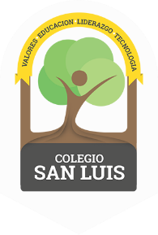
COLEGIO SAN LUIS
KINDER 1

Study guide

Math ( Monday March 4th and Tuesday March 5th ) .

- Numbers: from 7 to 9 (identify and trace).
- Shapes: Rectangle and Oval
- Opposites: Inside – outside, in front – behind
- Colors: Review the colors purple, red, yellow, green,
orange, pink and blue.
- Numbers: Count from 1 to 9.

Vocabulary ( Wednesday March 6th and Thursday March 7th ) .

- Vocabulary: Community Helpers and Means of transportation and communication.
- Letter: A,a - E,e – I,i (name, sound and trace).

