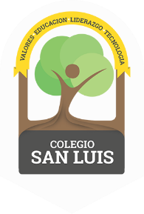
COLEGIO SAN LUIS
Kinder 2
Study Guide

Math Exam: March 4th and 5th .

- Count from 1 - 20
- Identify and write numbers from 1 to 20.
- Identify and trace shapes; Circle, Square, Triangle, oval, rectangle
- Opposites: More – Less, Over and Under, Day – Night
- Additons: 5 + 3 = 8 2 + 4 = 6

Phonics Exam: March 6th and 7th .

- Identify and write the Vowels ( cursive letters ).
- Identify, write and vocabulary for letters Ll, Kk, Bb, Hh, Oo, Ww, Xx
- (cursive letters ).
- Vocabulary: Community Helpers and Transportation.

Good Luck!
Miss Any, Miss Penny & Miss Regina

