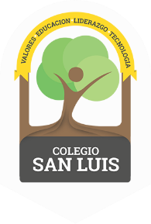

COLEGIO SAN LUIS
KINDER 1

Study guide
(

Math ( Monday 3th and Tuesday 4th ).

- Numbers: From 1 to 15.
- Shapes: Circle, triangle, square, star, heart, oval, rectangle and diamond.
- Opposites: Open – close, behind – in front, , up – down, big – small, inside – outside.
- Colors: Purple, gray, black, brown, green, red, blue, yellow
orange, pink and white.

Vocabulary ( Wednesday 5th and Thursday 6th ).

- Vocabulary: School objects, Family, Clothes, Toys, Community helpers, Means of transportation, Food, Fruits, Vegetables, Ecology and Animals.
- Letter: A,a - E,e – I,i – O,o and U,u (name, sound and trace).

