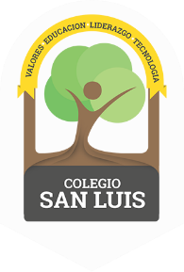
COLEGIO SAN LUIS
Kinder 2
Study Guide

Math Exam: Monday 3th and Tuesday 4th .

- Count from 1 - 30
- Identify and write numbers from 1 to 30.
- Identify and trace shapes: Circle, Square, Triangle, Oval, Rectangle, Star.
- Opposites: new – old, inside- outside, near – far.
- Additions (using numbers form 1 to 10)

Phonics Exam: Wednesday 5th and Thursday 6th.

- Identify and write the alphabet ( cursive letters ).
- Identify the name, vocabulary and sound of the letters.
- Vocabulary: Animals, Food, Transportation, Weather, Community helpers

Good Luck!
Miss Any, Miss Penny & Miss Regina

