Colegio San Luis

Study guide November 2019

Preprimary

**MATH: Monday November 11th.**

-Study number from 1 to 20 (count, trace and identify them).

Example: Count and write the number on the line. Review pages 29 .

-Place value: Example: Count and write the tens and ones in the correspond square.

**PHONICS: Wednesday, November 13th**

Review vocabularies /m/ and /s/ sounds.

Example: Write capital and lowercase next to the picture whose name begins with the sound /m/.



________________ ___ __________

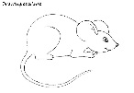

___ ______________ __________





________________ _ ___________

Example: write capital and lowercase next to the pictures whose name begins with the sound /s/.

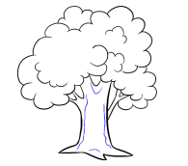___________ ___________ _________

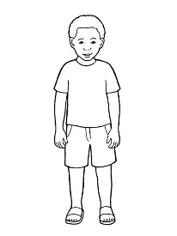

_____________ ___________

**GRAMMAR: Friday 15th**

* Circle the nouns for people, cross out the nouns for places, and color the noun for animal and things.

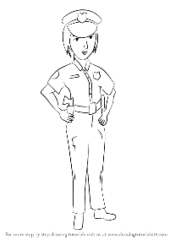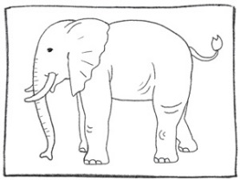



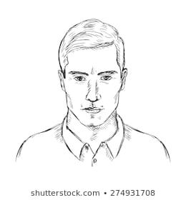

* Complete the sentences using the correct High Frequency Word.

|  |
| --- |
| the I like and |



1. I like _____



1. _____ like and ….

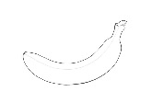

1. I ______ and .
2. 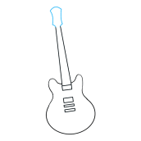I like _______ .