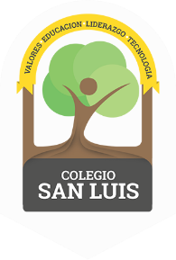
COLEGIO SAN LUIS
KINDER 1

Study guide
(September – October )

Math: November 11th and 12th
- Numbers: 1 and 2 (identify and trace).
- Shapes: Circle and Square (identify and trace).
- Opposites: Big-Small, Open-Close, Same-Different
- Colors: Red and Blue

Vocabulary: November 13th and 14th
- Vocabulary:
“School”
“Parts of the body”
“Family”
“Parts of the house”
- Vowel: A a (name, sound and trace).
Identify objects that begin with the letter A:
Example: apple, ambulance, ant, astronaut, alligator.

