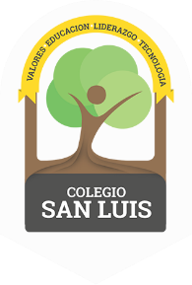
COLEGIO SAN LUIS
Kinder 2
Study Guide
September – October

Math Exam: November 11th and 12th

- Count from 1-10
- Identify and trace shapes: circle, triangle, square.
- Identify and write numbers from 1-10
- Opposites: long/short, small/big, inside/outside.
- Count and match

Phonics Exam: November 13th, 14th .

- Identify sound, name, and write the letters: Aa, Ee, Ii, Oo, Uu, Mm, Tt, Pp, Cc (cursive letters).
- Identify, trace and vocabulary for letters: Mm, Tt, Pp, Cc.
- Vocabulary: school supplies, family members, parts of the body.

