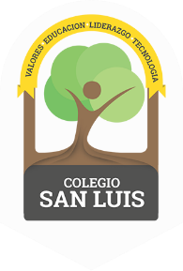
COLEGIO SAN LUIS
Kinder 2
Study Guide
December 2019

Math Exam: Monday 9th and Tuesday 10th
- Count from 1-15
- Identify and write numbers from 1 to 10.
- Identify and trace shapes: Circle, Square, Triangle, oval, rectangle, Star, Heart.
- Opposites; long/short, big/small, same/different, inside/outside.
- Complete patterns-sequences

Phonics Exam: Wednesday 11th and Thursday 12th
- Identify, write and vocabulary for letters Aa, Ee, Ii, Oo, Uu, Mm, Tt, Pp, Cc, Hh, Nn (cursive letters).
- Vocabulary: Clothing, School supplies, body parts, family members and Christmas.

Good Luck!
Miss Penny & Miss Camila

