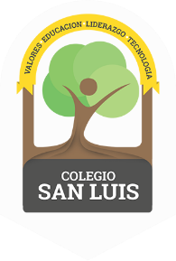
COLEGIO SAN LUIS
KINDER 1

Study guide
(January-February)

Math Exam: February 22nd and 23rd

- Numbers: 1,2,3,4,5,6, 7 (identify and trace).
- Shapes: Rectangle, oval, heart and star (identify and trace).
- Opposites: On- Under, In front of- Behind.
- Colors: Yellow- green- Pink-blue.

Vocabulary Exam: February 24th and 25th
Vocabulary:
Community Helpers
Means of transportation
- Vowel: I and i (name, sound and trace).
Identify objects that begin with the sound of the letter I.
Example: Indian, Iglu, Insect, Iguana.

