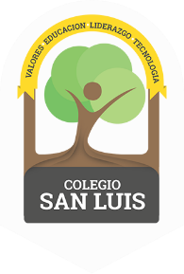
COLEGIO SAN LUIS
Kinder 2
Study Guide
February

Math Exam: February 22nd and 23rd.

- Count from 1-20
- Identify and trace shapes: star and heart.
- Identify and write numbers from 1-15.
- Count orally from 1-20.
- Opposites: in, on and under; tall and short.
- Count, match and complete.
- Manage the concept: One more-one less, tens and ones.

Phonics Exam: February 24th and 25th.

- Identify sound, name, and write the letters: Ff, Bb, Kk, Dd and Gg (cursive letters).
- Identify, trace and vocabulary for letters: Ff, Bb, Kk, Dd and Gg .
- Vocabulary: Community Helpers and Communication.
- Identify the colors: orange, pink and purple.

