Colegio San Luis
Preprimary Study Guide
May 2021

Name: ___________________________________
Wednesday, May 12th : Math exam
Friday, May 14th : Phonics exam
Monday, May 17th : Grammar exam

Math Study Guide
Let’s write the date of today below:

____________________________________

Let’s write the missing numbers that come before and after.

__, 29, __ __, 36, __, __ __, __, 19,__

__, 17 , __, __ __, 40, __ 13, __, __, __

44, __, __, 47 46, __, 48 __ 50

15__, __, 18, __, __, 21

Let’s count by 10’s

10 20 30 40 50 60 70 80 90 100

Fill in the missing 10’s in the chart

10 |  | 30
 |  | 60
 | 80

Have your counters ready
Adding

17 + 2 = __ 5 + 8 = __ 2 + 6 = __

16 + 3 = __ 11 + 4 = __ 3 + 8 = __

Subtracting

4 - 2 = __ 9 - 4 = __ 6 - 3 = __

7 - 5 = __ 10 - 2 = __ 8 - 7 = __

Phonics Study Guide

Name: ___________________________________

1- Write capital and lowercase letters for the sound you hear at the beginning of each name:

_________ ________ ________

_________ 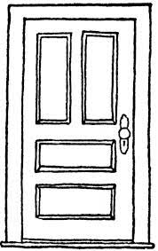________ _________

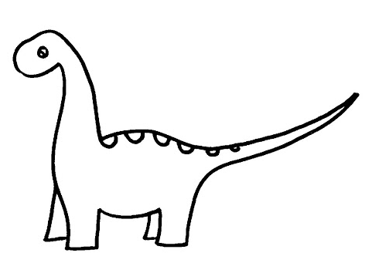________ _________ _________

2.- Circle the correct ending sound word that matches each picture.

sit pat fin van lit map

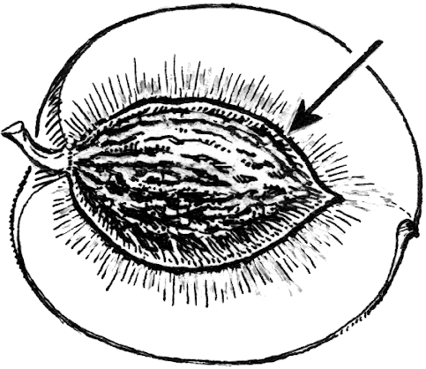
pin tan lap pit tin bin

mit hit fit bin kit fit

Grammar Study Guide
1.- Complete each sentence using the following High Frequency Words.

many - where - find - this - who - so - from – but- on - your - into – that - be - can

We will work in groups of 3 high frequency words

First Round:
Can How into

1.- _______ you sit here?

2.- ________ can I help you?

3.- Come ______ the classroom, please.

Second Round:
Where come but

1.- I like cats, ______ I like dogs more.

2.- ________ here, Nat cat!

3.- _________ is Pam rat?

Third round:
Find many Who

1.- Can you _______ my hat?

2.- _______ is this cat?

3.- I have ______ toys!

Fourth Round:
This that from

1.- I came _______ the cab.

2.- Pat can sit in ______.

3.- Who is _____ big, big pig?

Fifth Round:
Go they will

1.- _____ for it, Nan!

2.- Can you see my cat? _______ ran for it!

3.- Pam ______ be it now.

