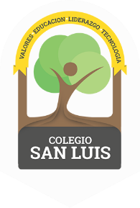
COLEGIO SAN LUIS
KINDER 1

Study guide
(March-April)

Math: May 11 and 12th.
- Numbers: From 1 to 13 (count, identify and trace).
- Shapes: Diamond (identify and trace).
- Opposites: Day-Night
- Colors: Orange-Purple.

Vocabulary: May 13th and 14th
- Vocabulary:
Food: apple, banana, cake, milk, juice, pineapple, watermelon, tomato, chicken, potato, eggs.
Weather: sunny, windy, rainy, snowy, cloudy.
- Vowel: O and U (name, sound and trace).
Identify objects that begin with the sound of the letter / Oo and Uu /.
Example:
O: orange, onion, octopus, oven.
U: Umbrella, up, underwear, ugly, umpire.

