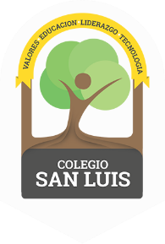
COLEGIO SAN LUIS
Kinder 2
Study Guide
April

Math Exam: May 11th and 12th.

- Identify and write numbers from 1-25.
- Count orally from 1-30.
- Identify and trace shapes: circle, square, rectangle, triangle, diamond, heart and star.
- Prepositions: in, on and under, in front, behind, next to and between.
- Count, match and complete.
- Manage the concept: One more-one less, tens and ones.

Phonics Exam: May 13th and 14th.

- Identify sound, name, and write the letters: Jj, Ll, Ss, Rr, Ww, Yy and Vv (cursive letters).
- Identify, trace and vocabulary for letters: Jj, Ll, Ss, Rr, Ww, Yy and Vv .
- Vocabulary: Mean of Transportation and Fruits and Vegetables.
- Identify the colors: Answer the question and represent the colors with drawings.

