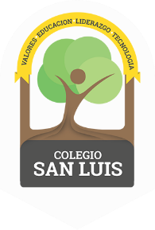
COLEGIO SAN LUIS
Kinder 2
Study Guide
June

Math Exam: June 14th and 15th.

- Count from 1-30
- Identify and trace shapes: circle, square, rectangle, triangle, diamond, heart and star.
- Identify and write numbers from 1-30.
- Count orally from 1-30.
- Prepositions: in, on and under, in front, behind, next to, after, before and between.
- Count, match and complete.
- Manage the concept: addition and subtraction, tens and ones.

Phonics Exam: June 16
^{th} and 17th.

- Identify sound, name, and write the alphabet: (cursive letters).
- Identify and trace the vocabulary of all the letters.
- Vocabulary: School objects, Family, Clothes, Toys, Community helpers, Means of transportation, Food, Fruits, Vegetables, Ecology and Animals.

