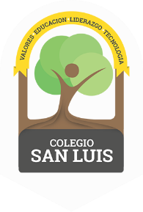
COLEGIO SAN LUIS
KINDER 1

Study guide
(September – October 2021)

Math: October 18th and 19th

- Numbers: 0, 1 and 2 (identify and trace).
- Shapes: Circle and Square (identify and trace).
- Opposites: Big-Small, Open-Close
- Colors: Red, Blue and yellow
- Count and match objects: one and two

Vocabulary: October 20th and 21ST
- Vocabulary:
“School objects”
“Family members”
“Parts of the face”
- Vowel: A a (name, sound and trace).
Identify objects that begin with the sound of the letter A:
Example: apple, ambulance, ant, astronaut, alligator.

