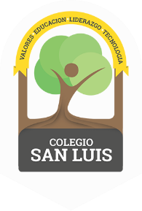
COLEGIO SAN LUIS
KINDER 1

Study guide
December 2021

Math: Monday December 6th and Tuesday 7th 2021
Numbers: 0,1,2,3 (identify, trace and count).
- Shapes: Circle, Square and Triangle (identify and trace).
- Opposites: Up- Down, In- out, Big- Small
- Colors: Yellow- green- purple.

Vocabulary: Wednesday December 8th and Thursday 9th, 2021
- Vocabulary:
“School Objects” “Clothes” “Parts of the face”
- Vowel: / A a / E e / (name, sound and trace).
Identify objects that begin with the sound of the letter / E e /.

