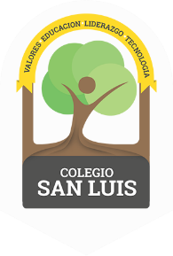
COLEGIO SAN LUIS
Preprimary
Study Guide
August-December 2021

Math Exam: December 6th.

- Identify the name of numbers from 1 to 30.
- Identify and write numbers from 1-30.
- Count orally from 1-30.
- Measure objects with number line.
- Size: Biggest, smallest/longest, shortest/ tallest and shortest.
- Manage the concept: Tens and ones.

Phonics Exam: December 8th.

- Identify the beginning sound of: Cc, Aa, Pp and Tt.
- Identify and write the ending sound of: an-at.
- The name writing in cursive: name and last name. E.g. Mónica Villalobos.

Grammar Exam: December 10th.
- Nouns: Name of colors and numbers.
- Nouns: Places, people, animals and things.
- High Frequency Words: I, we, like, see, a, the, and.

