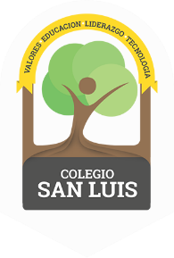
COLEGIO SAN LUIS
KINDER 1

Study guide
September-October 2022

Math: Monday 17th and Tuesday 18th
Numbers: 0,1,2 (identify, trace and count).
- Shapes: Circle and Square (identify and trace).
- Opposites: Up- Down, In- out, Big- Small
- Colors: red, blue and green.

Vocabulary: Wednesday 19th and Thursday 20th Vocabulary:
“School Objects”, Body’s Part and Members Family”
- Vowel: / A a / (name, sound and trace).
Identify objects that begin with the sound of the letter / A a /.

