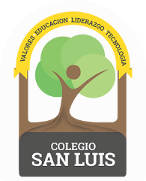
Kinder 2
Study Guide
September/October 2022

Math exam:
Monday October 17th and Tuesday October 18th

- Count from 1-10
- Identify and write numbers 1, 2, 3, 4 , 5.
- Identify and trace shapes; Circle, Square, Triangle
- Opposites; Long-Short, Tall-Short, On-In, Big-Medium-Small, Top-Bottom

Phonics and Vocabulary exam:
Wednesday October 19th and Thursday October 20th

- Identify name, sound and trace of the Vowels.
- Vocabulary: Vowels ( a, e, i, o, u ).
- Vocabulary: School Supplies, Parts of the body and Family Members.

Good Luck!

