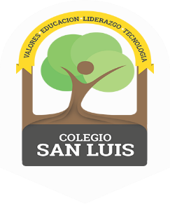
Colegio San Luis - Preprimary
Study Guide Phonics
September-October 2022

Phonics Exam: October 19th, 2022

Name: ______________________________

1.- Review the alphabet, name, sound and trace.

 |  | Bb |  | Dd
Ff |  |  | Hh |  | Jj
 |  | Ll |  | Nn
Pp |  |  | Rr |  | Tt
 |  | Vv |  | Xx
Xx

2.- Identify the pictures that begin with the sound of the letter / Mm /.

_____________________ ____________________ ________________

_____________________ ____________________ ________________

Colegio San Luis - Preprimary
Study Guide Grammar
September- October 2022

Grammar Exam: October 21st , 2022

Name: _________________________________

1.- Identify people, place, animals and things.
Place and things = color
Animals = circle
People = cross out

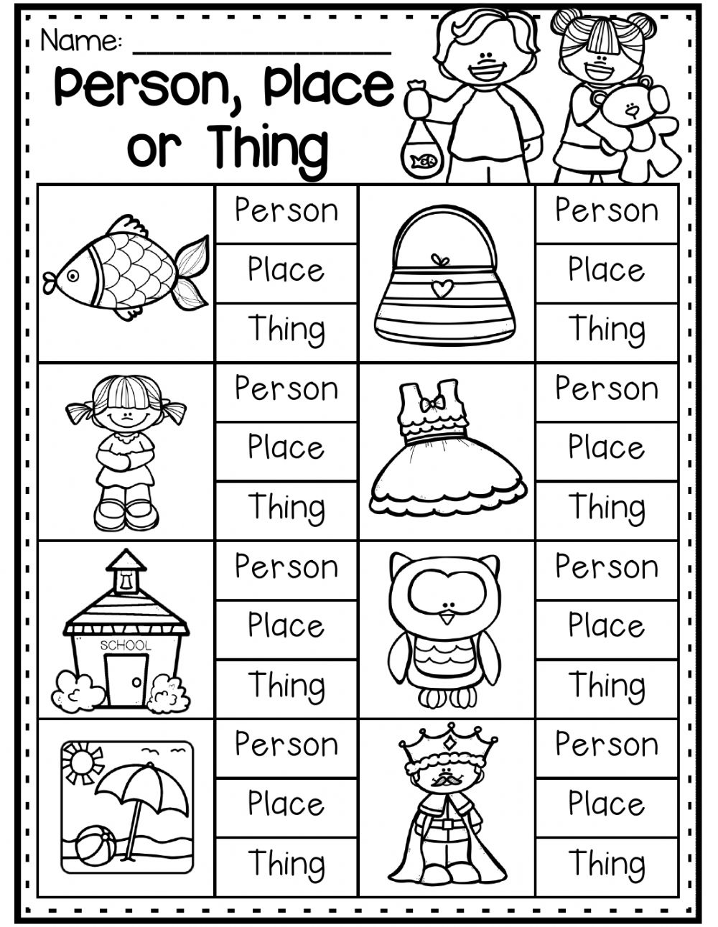

I like

2.- Complete the sentences using the correct High Frequency Word.

1._____ like . 2. I ______ .
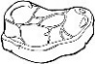
3. I _____ . 4. ____
Colegio San Luis – Preprimary
Study Guide Math
September-October 2022

Math Exam: October 17th, 2022

1.- Ordinal numbers. Example: Color purple the ball that is in the second place, red first, green fifth, yellow third, blue fourth.
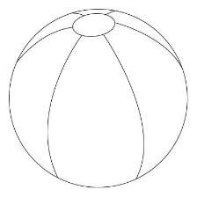

1st 2nd 3rd 4th 5th

2. More-less. Color Yellow more, green less.

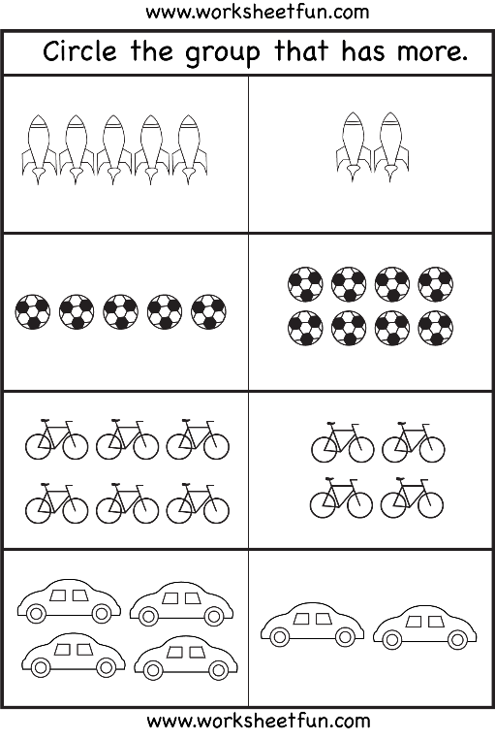

3. Write and say the numbers from 1 to 10.

0 |  | 2 | 3 |  |  | 6 |  | 8
 | 1 |  | 3 |  | 5 |  | 7 |  | 9 | 10
 |  | 2 |  | 4 |  | 6 |  | 8 |  | 10

