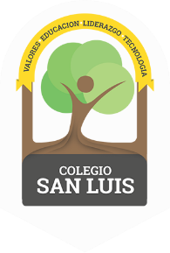
COLEGIO SAN LUIS
KINDER 1

Study guide February 2023

Math: Monday February 27th and Tuesday 28th 2023
Numbers: 0,1, 2, 3, 4, 5, 6, 7, 8 (identify, trace and count).
- Shapes: Rectangle, oval and diamond (identify and trace).
- Opposites: On – under.
- Colors: Pink, orange, white.

Vocabulary: Wednesday March 01st and Thursday 02nd 2023
- Vocabulary: “Community Helpers” “Means of transportation”.
- Vowels: Identify objects that begin with the sound of the letters / A a – E e - I i / and the cursive /a, i /.
- Trace, sound and vocabulary of the letter / I i /.
(Indian, iguana, igloo, insect).

