Colegio San Luis
Study Guide Phonics
February 2023
Preprimary

Phonics Exam: Wednesday March 1st, 2023

Write your name: _____________________________________

1.- Write capital and lowercase letters for the sound you hear at the beginning of each name.

2.- Circle the correct ending sound word that matches each picture.

cat rat lap map can fan

man pan mat hat nap cap

bad mad jam ham rat fat

Pam ram pad sad tap nap

Colegio San Luis
Study Guide Grammar
February 2023
Preprimary

Grammar Exam: Friday March 3rd , 2023

1.- Complete each sentence using the following High Frequency Words.

are with my what now

1.- _________________ you Sam?

2.- _________________ come with me!

3.- See ______________ cat.

4.- _________________ can you see?

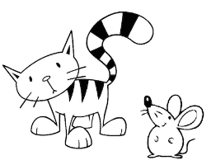
5.-We see my cat _________________ a rat?

Colegio San Luis
Study Guide Math
February 2023
Preprimary

Math Exam: Monday, February 27th 2023
1.- Find the missing number! What comes before and after the numbers show below?

_____, 5, _____ _____, 10, _____ _____, 15, _____

_____, 20, _____ _____, 25, _____ _____, 30, _____

_____, 33, _____ _____, 38, _____ _____, 42, _____

_____, 45, _____ _____,48 , _____ _____, 49, _____

2.- Write the days of the week in our own handwriting.

Monday _____________________

Wednesday __________________

Friday ______________________

Saturday____________________

3.- Write the months in a year in our own handwriting.

January _____________________ August _____________________

March _____________________ October _____________________

May ______________________ November _____________________

June ____________________ December _____________________

4.- Write the time in the box below the clock.

