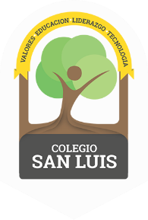
COLEGIO SAN LUIS
KINDER 1

Study guide
( November – December 2018).

Math ( Wednesday 5th and Thursday 6th).
- Numbers: 3 and 4 (identify and trace).
- Shapes: Triangle and square (identify and trace).
- Opposites: Up – down, on – under.
- Colors: Orange and Green

Vocabulary (Friday 7th and Monday 10th).
- Vocabulary: Clothes and Parts of the body.
- Letter: / A a ) , / E e / (name, sound and trace).

