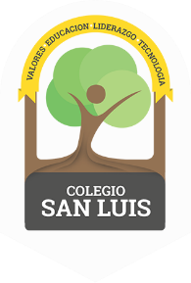
COLEGIO SAN LUIS
Kinder 2
Study Guide
December 2018

Math Exam: Wednesday 5th and Thursday 6th
- Count from 1-15
- Identify and write numbers from 1 to 9.
- Identify and trace shapes; Circle, Square, Triangle, oval, rectangle
- Opposites; in front of-behind, around, different, in, on, under.
- Complete patterns-sequences

Phonics Exam: Monday 10th and Tuesday 11th
- Identify and write the LETTERS Mm, Nn, Ss, Rr, Tt, Cc, Ff, I i, Dd, Gg, Aa ( cursive letters ).
- Identify, write and vocabulary for letters Aa, Nn, Dd, Ff, Gg, I i. ( cursive letters ).
- Vocabulary: Clothing, Christmas and Toys.

Good Luck!
Miss Any, Miss Penny & Miss Regina

